# **Setup Steps**

We can follow the below each section to run the application normally.

## **Code Download**

1. Latest code can be downloaded from GitHub and below folders are present in the download. (<https://github.com/keerthika-srinivasan/GitHub>)
   1. Database
   2. InputFile
   3. Web
   4. Windows

## **Database Setup**

1. Under folder database restore the backup file to the sql 2014 database.
2. Follow below screenshot flow for detailed restoration steps.

### DB Restore Flow ScreenShots:

1. Restore the Database from the Database folder-Database Name(FraudDetector.bkp)

**Right click the Database and click Restore database**

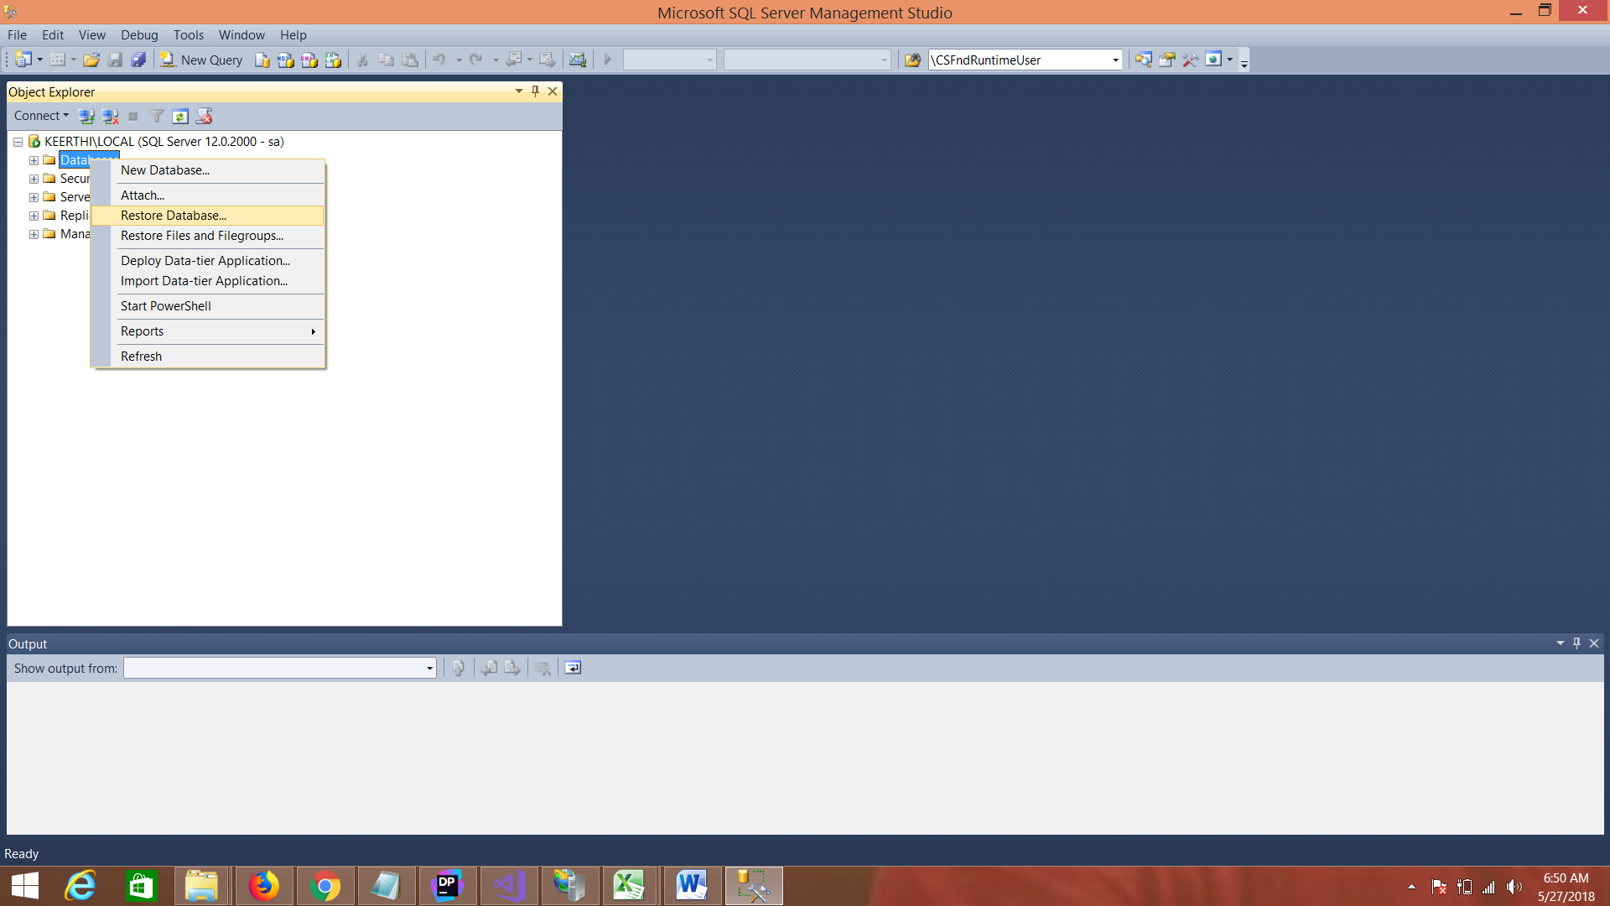

Select the Device option and click on the button opposite to the Device Selector

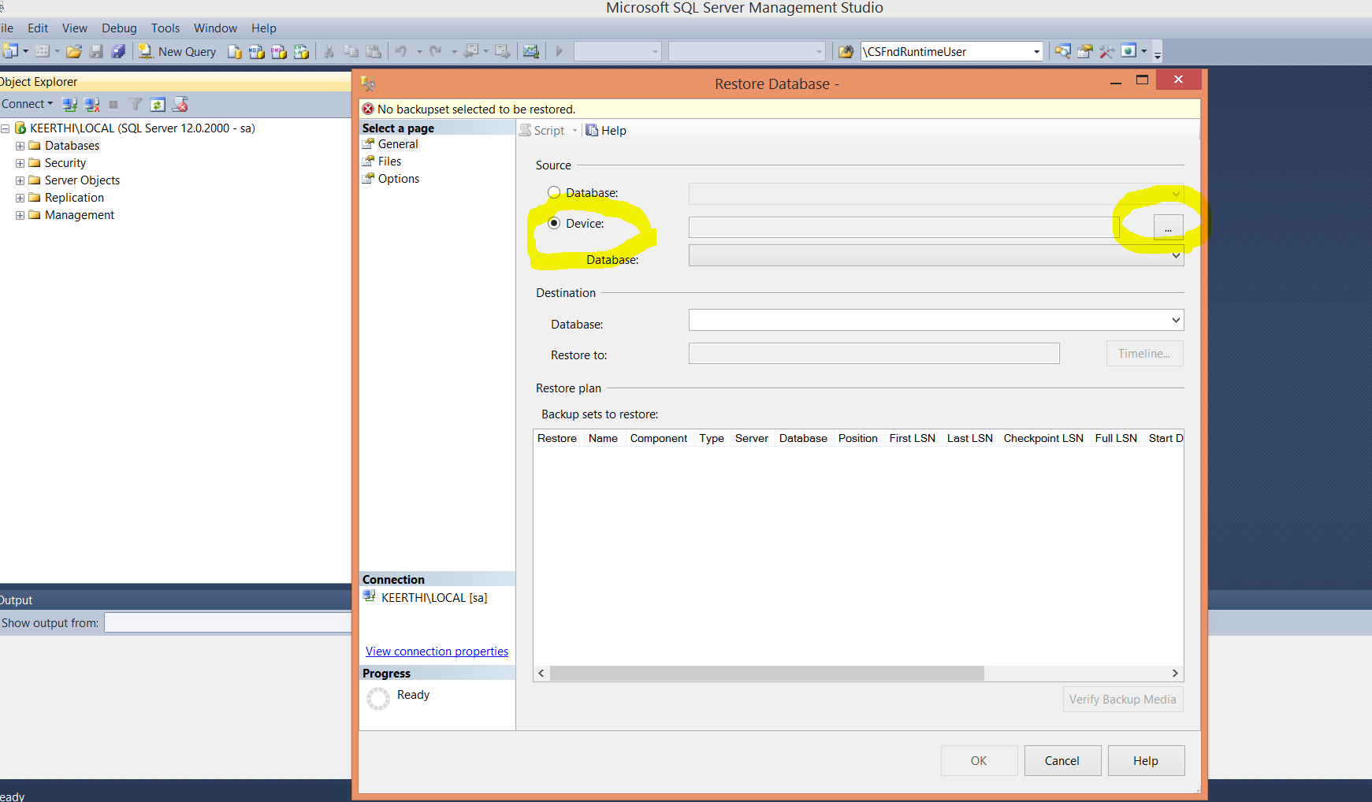

Click the add button

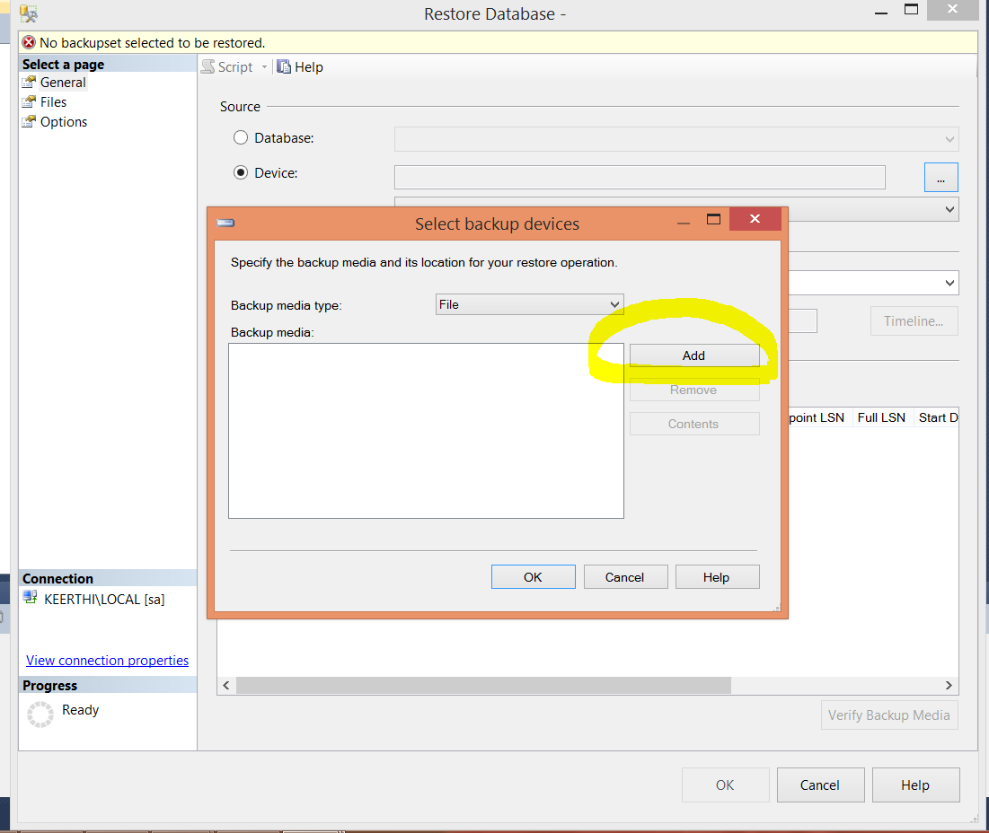

Specify the downloaded file database backup file path

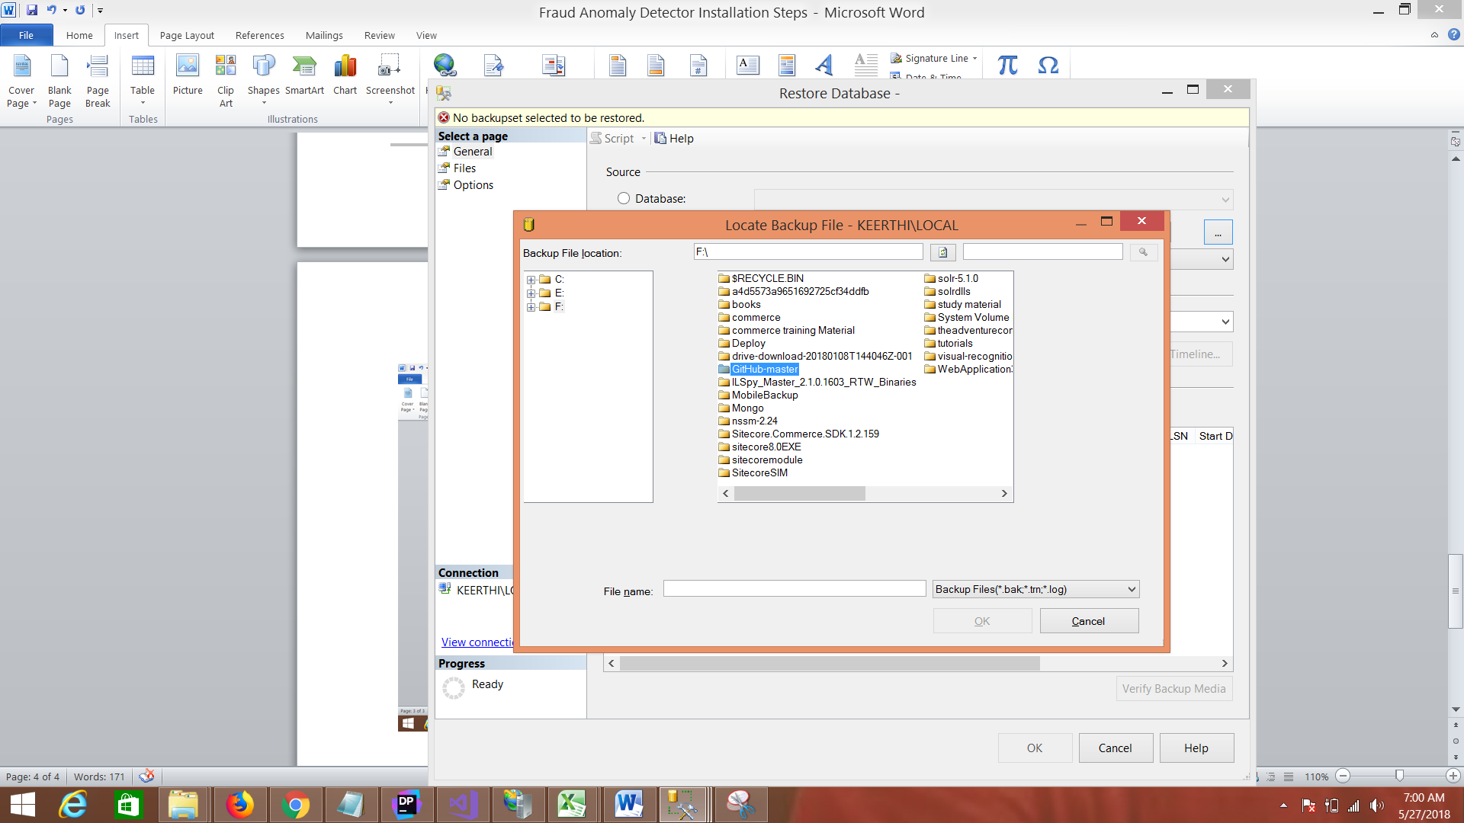

Navigate to the folder database

Select the filetype so the database will be visible and click on the database.so that the ok button will be enabled.

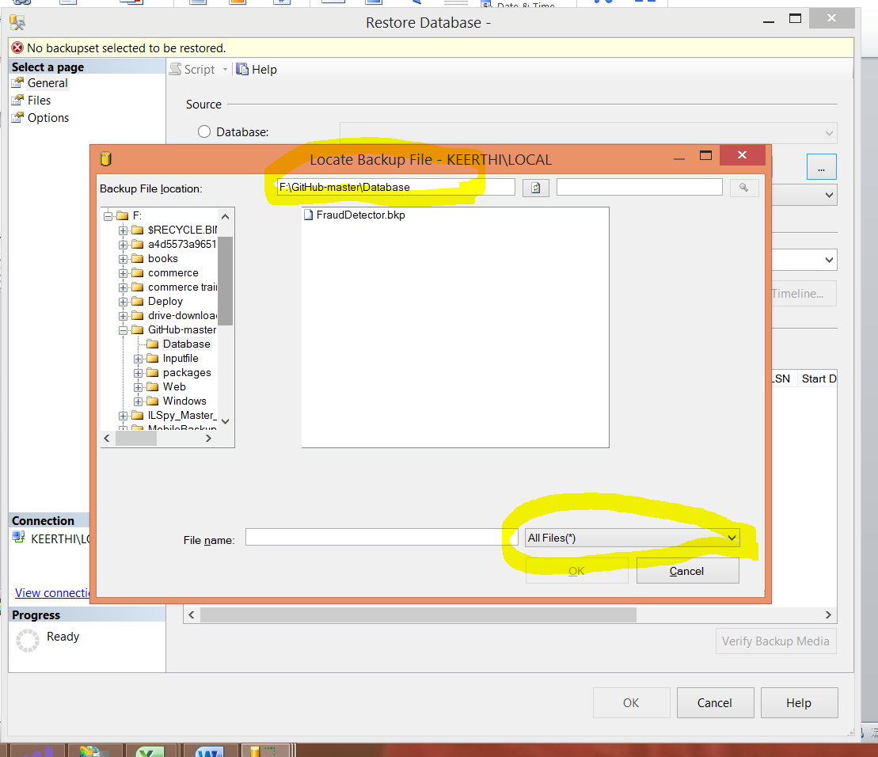

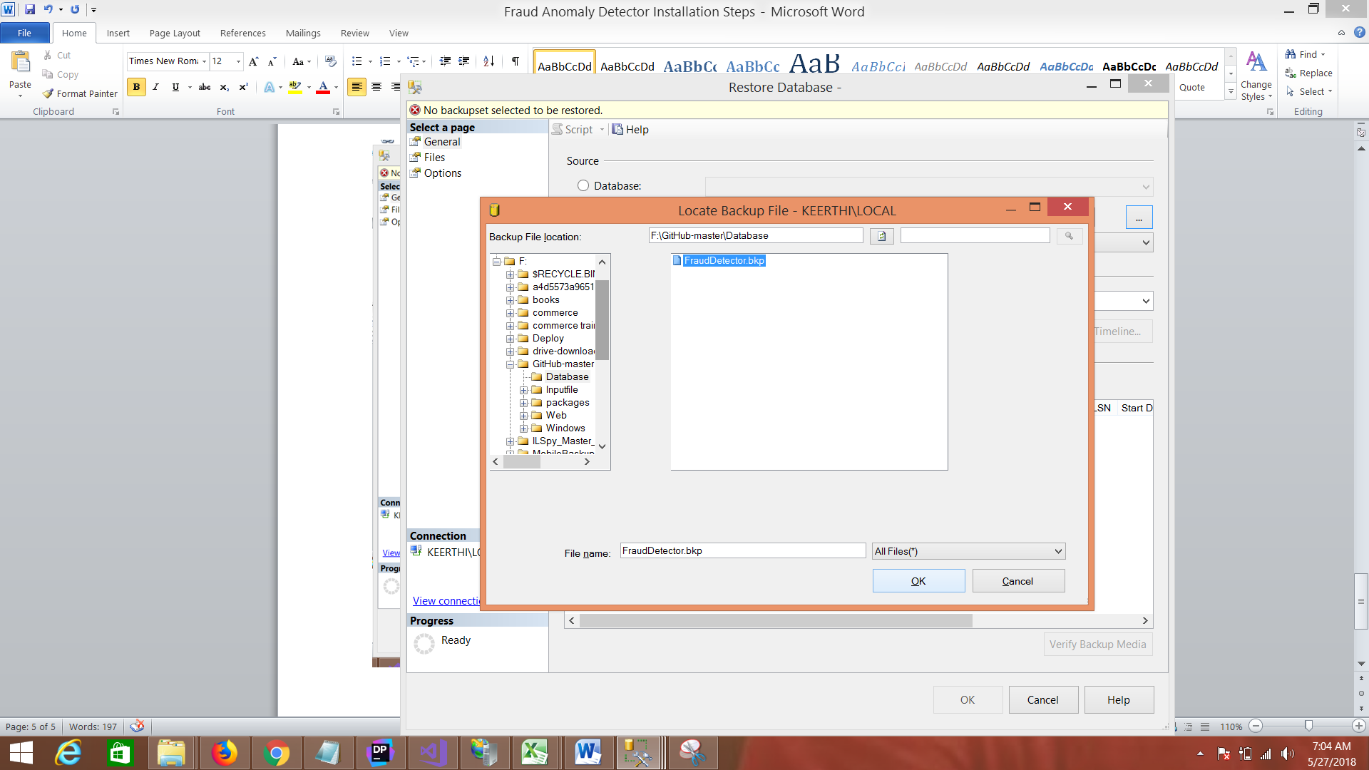

And Click ok.

Select the options button and select the overwrite option and click ok button

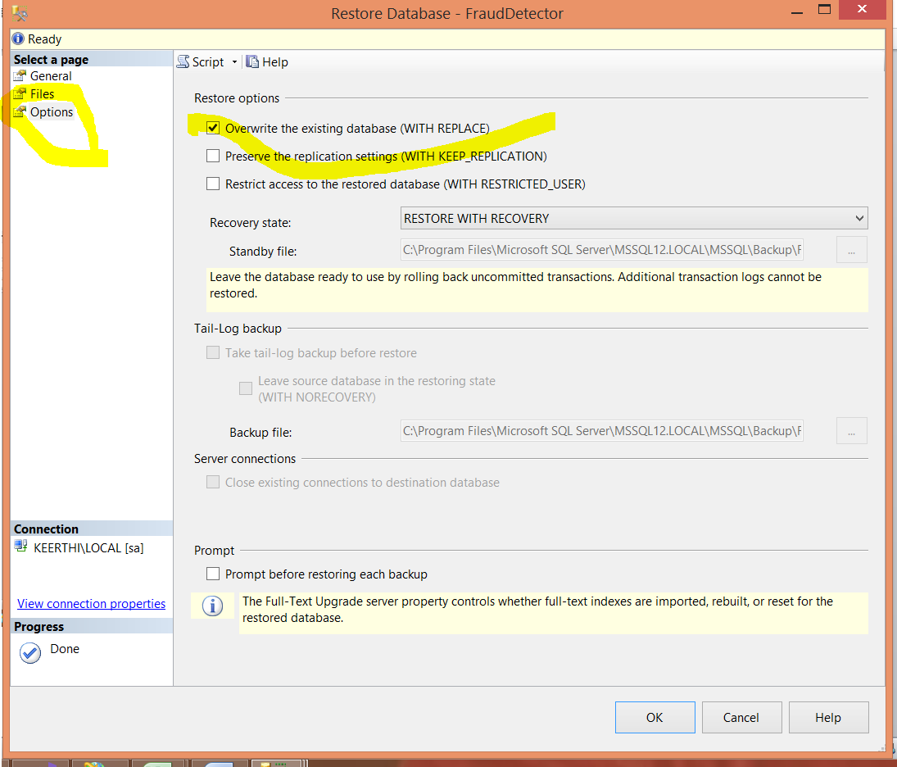

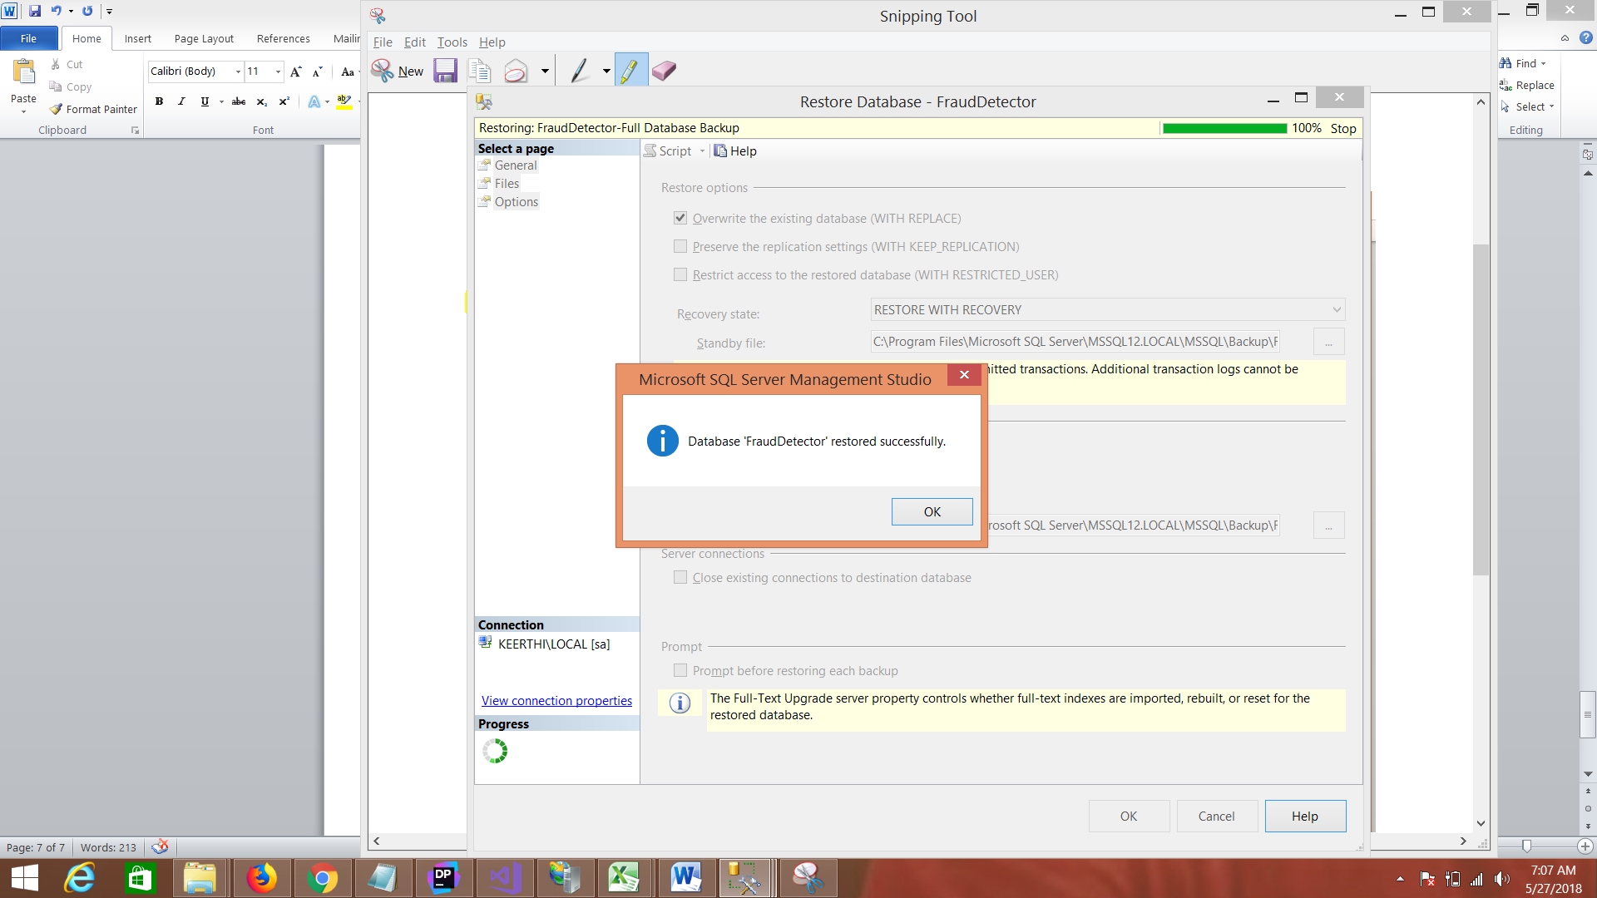

**Database restore is completed**

## **Web Application Setup**

1. Open the Solution File under web\[FraudDetector.sln](https://github.com/keerthika-srinivasan/GitHub/blob/master/Web/FraudDetector.sln) with VS2017.
2. Open the File under CoreEngine Class library 🡪 CoreEngine\Repository\BaseRepository.cs
   1. Change the conncetion string in Line no 14 as per the database setup.
3. Build the application.
4. Configure the IIS to Point to the Solution or we can create an instance in IIS and publish this code base to the same.
5. Add the Host entry if you are creating a new websiteName (hostname) for the instance.
6. Hit the URL in localhost or hostname as per the IIS setup that you do.

## **Windows Application Setup**

1. Open the solution File under Windows\[FraudDetector.Win.sln](https://github.com/keerthika-srinivasan/GitHub/blob/master/Windows/FraudDetector.Win.sln) with vs2017.
2. Open the File under CoreEngine Class library 🡪 CoreEngine\Repository\BaseRepository.cs
3. Change the conncetion string in Line no 14 as per the database setup.
4. Build the application and run in Start without debugging mode.